1. Visit [www.nohat.io](http://www.nohat.io)
2. Click on “Get Started”

1. Click on Download to download the NoHat Software

1. right click on the folder and “Extract all”

1. Extract to any destination of choice. In my case “C:\Users\{username}\Downloads\MonitoringService”

1. You will see the following completion page.
2. Double click on NoHATService to install the software.

1. Click on “more info” and “Run anyways”

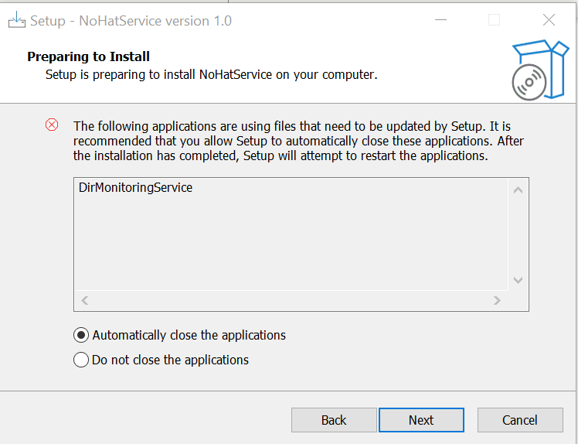

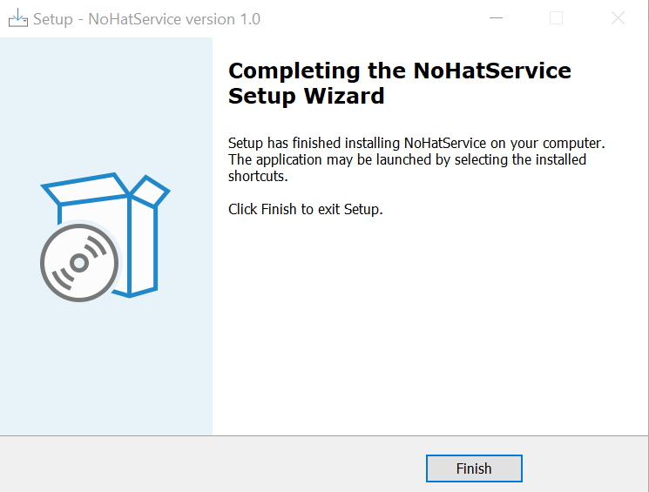

Goto your desktop you will see the following software, double click on NoHATUI



